What is a Data Model?
Consider relationships view that looks like this. We got three different tables here. A product lookup table and two data tables, sales and returns. This alone is not a data model. What we’re looking at here is a collection of independent tables which share no connections or relationships. So, think of each of these tables as its own little island, with no idea that the other two even exist in the model.
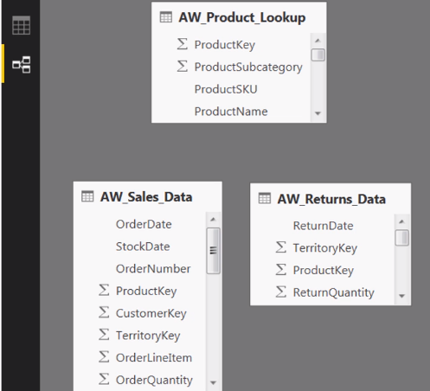
What that means is that if you were to try to do something like breaking down a field from the sales data like order quantity or a field from the returns table like return quantity and break those quantities down by a field from the product lookup table, you’re going to get the same grand total in every single row of the table.
That’s because both the sales and the returns data tables have no idea that there even is a product lookup table that exists in the universe, let alone how to break down those quantity values by individual product names. So, if this is not a data model, then what is?
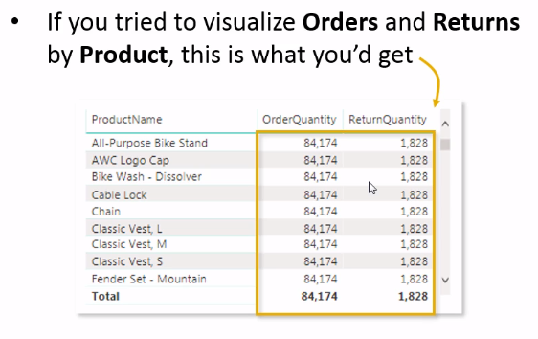
Well, let’s consider the same structure, the same relationships view. Except now we have relationships connecting the tables together. This is a data model. It’s a data model, because the tables are now connected via relationships based on a common field or key, which in this case is the product key column. What this means is that if we revisit the same analysis looking at order quantity and return quantity by product names, now we see the correct values because now the sales data table knows that the product lookup table exists.
In fact, it’s connected to that product table based on the fact that they share a common product key. And the same story holds for the returns data and its relationship to the product lookup. As a result, we’re able to take any field from the product lookup table and filter and segment values from those two data tables. You’ll see that same familiar grand total row at the bottom, but now we get accurate numbers for each individual product.
This is the core concept of joining and blending our data together, using table relationships and common keys that will be the focal point of this entire section of the course. And it’s this core concept that’s going to enable us to do some really interesting, really sophisticated analysis.
